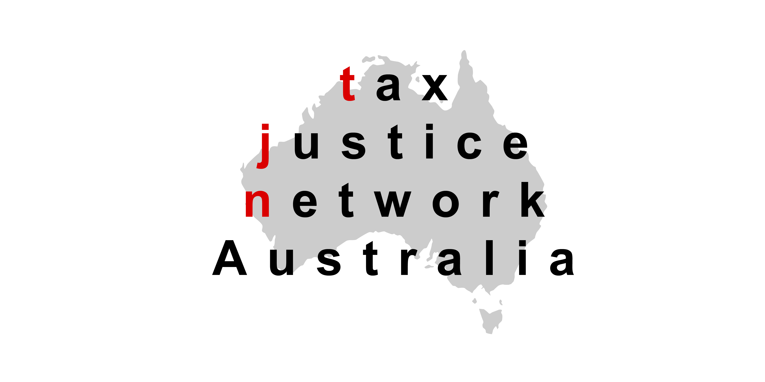
The Board of Taxation
c/ The Treasury
Langton Crescent
CANBERRA ACT 2600
E-mail: taxtransparency@taxboard.gov.au

Tax Justice Network Australia Submission on
‘A tax transparency code’
29 January 2016

The Tax Justice Network Australia (TJN-Aus) welcomes the opportunity to make a submission to the Board of Taxation ‘A tax transparency code’. It is welcome that the Board is encouraging businesses to make a greater effort to explain their tax affairs. However, the Board’s recommendations are currently so flawed, the Code should be abandoned as it will serve no useful purpose. Businesses will continue to be subject to public pressure to explain their tax affairs. Given the weak nature of the Board’s recommendations, government should simply let businesses develop voluntary disclosures of their own. Government should continue to increase mandatory disclosure measures to level the playing field between those businesses that lead by example with accurate voluntary disclosures and those that continue to hide behind a veil secrecy over their tax affairs.

While the content of the proposed Code would add some additional tax information for some companies that choose to comply with the Code, it is deeply disappointing the Board has recommended against any reporting on a country-by-country basis of corporate revenue, profits, taxes paid, assets and employees, which would allow the community to gain a picture of if the location of a company’s profits are being “taxed where the economic activities deriving the profits are performed and where value is created.” This is contrary to what has largely already required been a mandatory measure in the EU for financial institutions. See for example the reporting by Deutsche Bank at https://annualreport.deutsche-bank.com/2014/ar/notes/additional-notes/45-country-by-country-reporting.html.

Further, the Code is undermined by decision there will be no verification of the information in the reports made by the companies and no penalties for companies making false or misleading reports. It would seem obvious that a company wilfully engaged in tax avoidance or aggressive tax planning that is skirting what might be legal, would be likely to have little concern about making false or misleading reports against the Code if they believe no one will detect that the information is false or misleading and where no penalty exists for doing so. This is likely to result, understandably, in a high degree of scepticism about the Code. Further, the Code could even serve to provide cover to a company engaged in tax avoidance, to create a false impression of voluntary transparency. Should this be publicly discovered to happen, the credibility of the Code will be further damaged.

If the Code will not be subject to any verification of its accuracy by the body assigned to administer it, then the ATO should not be the body to administer the Code. The ATO being associated with what might later be exposed as false or misleading reports would greatly damage the credibility and reputation of the ATO. It would be better, in such circumstances that the Code reports simply be published on a website administered by a private business body or on the businesses’ own websites, so that government in no way adds credibility to the reports. In that way, each Code report can simply be assessed on its own merits by the community and interested parties. Businesses that make accurate and informative disclosures will still receive positive acknowledgement for having done so.

Contrary to the optimism of the Board of Taxation for voluntary disclosure, the evidence that an increasing number of companies operating in Australia are choosing to reduce the amount of financial information they voluntarily place in the public sphere. While there are commendable examples of corporations that have increased their tax transparency, many do not disclose any financial information (ALDI and Ikea being examples), others produce very basic special purpose financial statements (P&G, Unilever and Johnson & Johnson), which are almost useless and large numbers use Reduced Disclosure Requirements of the Australian Accounting Standards Board. Given these trends, the optimism of the Board of Taxation that the Code will generate greater voluntary and credible financial reporting on tax affairs seems misplaced.

Using the example of declining voluntary disclosure from another jurisdiction, Jeffrey Gramlich of the Hoops Institute at Washington State University and Janie Whiteaker-Poe of Baylor University crunched data at The Economist’s request and found a sharp increase since 2010 in the number of American firms dramatically reducing the number of tax-haven subsidiaries they disclosed. In one extreme case Google reported more than 100 divisions in 2009, but just two (both in Ireland) in 2012. Mr Gramlich argued that there is a mass redefinition of subsidiaries as not “significant”. Only material holdings have to be disclosed in US and Australia (whereas in, say, Germany all have to be reported). The Economist speculated that firms would never admit it, but the likely reason for this redefinition is increased scrutiny of their tax affairs. The Economist argued that MNEs “move into the dark coincided with a surge in investigative articles about profit-shifting by multinationals.” The Economist took the view that not all the redefining is likely to be legal, but the companies are willing to take the risk: the most they can be fined in the US for de-disclosing significant subsidiaries is US$100 a day.

It is very disappointing that the Board has rejected the ATO ‘effective tax borne’ method for inclusion in the Code.

Royalties should not be included in the Code, as these are usually not taxes. For example, in the case of mineral deposits, these are payments a mining company makes to the owner of the deposit (in this case a government), to purchase this raw material.

The Code should not include a recommendation that it include taxes collected by the business on behalf of others, as the focus of the Code should be strictly on the taxes paid by the business.

The TJN-Aus supports disclosures being made in plain English with the use of charts, diagrams and trend data over a number of years.

Tax transparency can have a positive effect in reducing aggressive tax practices of businesses, but this is most effective where the tax transparency has been mandated or companies have been exposed as engaging in aggressive tax practices. The Oxford University Centre for Business Taxation found that FTSE 100 firms that were exposed by ActionAid as not compliant with subsidiary disclosure rules (non-compliant firms) reported higher effective tax rates (ETRs) following the public scrutiny. In the view of the Centre for Business Taxation this indicated a decrease in tax avoidance relative to FTSE 100 firms that were not affected by the scrutiny (compliant firms). Specifically, their estimates suggest a 3.7 percentage point increase in the ETRs of non-compliant firms relative to the ETRs of compliant firms in the years following the initial public pressure to comply with disclosure of all subsidiaries. The 34 firms subject to the scrutiny treatment in 2010 had median pre-tax book income of £618 million. Using a simple calculation, a 3.7 percent increase in ETR indicates increased tax expense of roughly £23 million per firm.

In addition, the Centre of Business Taxation found the decrease in tax avoidance for non-compliant firms in the post-scrutiny period is most pronounced in the subsample of firms that experience a decrease in the percentage of total subsidiaries located in small tax haven countries – countries where subsidiaries are unlikely to have operational substance. In their view, these results suggest that non-compliant firms responded to negative public scrutiny by decreasing subsidiary use in locations where they would incur high disclosure costs (for example, political and reputational costs arising from increased scrutiny from tax authorities, customer and political outcry, or market penalties) and where it would be relatively easy to close subsidiaries without generation significant operating costs.

The Oxford University Centre for Business Taxation found that the evidence suggested that firms behave as though public scrutiny of tax avoidance activities is costly. They posited that reputational concerns of tax avoidance are likely to be concentrated in a specific kind of firm that is sensitivity to public scrutiny of disclosure that reveals tax-related information.

Recommendations
The TJN-Aus recommends the proposed Tax Transparency Code be abandoned with unless the following the following two measures are adopted:
- Require country-by-country disclosure of revenue, profits, taxes paid, assets and employees as part of the Code;
- Require verification of the information reported by companies by the ATO, to avoid false or misleading information being presented that undermines the credibility of the Code and any government agency associated with reports made under the Code.

Further:
- The Board should work with the ATO to develop a credible effective tax rate, that the ATO would consider gives the community the most useful indication of the tax rate relevant to the business;
- The Code should not include royalty payments in any way that implies they are taxes.
- The Code should not include a recommendation that it include taxes collected by the business on behalf of others.

Dr Mark Zirnsak
Secretariat
Tax Justice Network Australia
c/- 130 Little Collins Street
Melbourne, Victoria, 3000
Phone: (03) 9251 5265
E-mail: mark.zirnsak@victas.uca.org.au

Appendix: Background on the Tax Justice Network Australia
The Tax Justice Network Australia (TJN-Aus) is the Australian branch of the Tax Justice Network (TJN) and the Global Alliance for Tax Justice. TJN is an independent organisation launched in the British Houses of Parliament in March 2003. It is dedicated to high-level research, analysis and advocacy in the field of tax and regulation. TJN works to map, analyse and explain the role of taxation and the harmful impacts of tax evasion, tax avoidance, tax competition and tax havens. TJN’s objective is to encourage reform at the global and national levels.

The Tax Justice Network aims to:
(a) promote sustainable finance for development;
(b) promote international co-operation on tax regulation and tax related crimes;
(c) oppose tax havens;
(d) promote progressive and equitable taxation;
(e) promote corporate responsibility and accountability; and
(f) promote tax compliance and a culture of responsibility.

In Australia the current members of TJN-Aus are:
- ActionAid Australia
- Aid/Watch
- Australian Council for International Development (ACFID)
- Australian Council of Trade Unions (ACTU)
- Australian Education Union
- Anglican Overseas Aid
- Baptist World Aid
- Caritas Australia
- Columban Mission Institute, Centre for Peace Ecology and Justice
- Community and Public Service Union
- Friends of the Earth
- GetUp!
- Global Poverty Project
- Greenpeace Australia Pacific
- International Transport Workers Federation
- Jubilee Australia
- Maritime Union of Australia
- National Tertiary Education Union
- New South Wales Nurses and Midwives’ Association
- Oaktree Foundation
- Oxfam Australia
- Save the Children Australia
- SEARCH Foundation
- SJ around the Bay
- Social Policy Connections
- Synod of Victoria and Tasmania, Uniting Church in Australia
- TEAR Australia
- Union Aid Abroad – APHEDA
- UnitedVoice
- UnitingWorld
- UnitingJustice
- Victorian Trades Hall Council
- World Vision Australia

G20 Leaders’ Communique, Brisbane Summit, 15-16 November 2014, p. 2.
‘Corporate transparency: The openness revolution’, The Economist, 13 December 2014.
‘Corporate transparency: The openness revolution’, The Economist, 13 December 2014.
‘Corporate transparency: The openness revolution’, The Economist, 13 December 2014.
‘Corporate transparency: The openness revolution’, The Economist, 13 December 2014.
Scott D. Dyreng, Jeffrey L. Hoopes and Jaron H. Wilde, ‘Public Pressure and Corporate Tax Behaviour’, Oxford University Centre for Business Taxation, September 2014, p. 4.
Scott D. Dyreng, Jeffrey L. Hoopes and Jaron H. Wilde, ‘Public Pressure and Corporate Tax Behaviour’, Oxford University Centre for Business Taxation, September 2014, p. 21.
Scott D. Dyreng, Jeffrey L. Hoopes and Jaron H. Wilde, ‘Public Pressure and Corporate Tax Behaviour’, Oxford University Centre for Business Taxation, September 2014, pp. 4-5.
Scott D. Dyreng, Jeffrey L. Hoopes and Jaron H. Wilde, ‘Public Pressure and Corporate Tax Behaviour’, Oxford University Centre for Business Taxation, September 2014, p. 6.

